Guanzhen Qian

Per 6-8 Cisco CCNP

OSPFv2 Lab Write Up

Purpose

Set up five routers and five end devices with OSPFv2 and OSPFv3 running as IP route protocol between different networks. There are two areas in this lab. The goal is to make end devices able to connect to each other (ping each other).

Background Information on lab concepts

Open Shortest Path First (OSPF) is a routing protocol for Internet Protocol (IP) networks. OSPF was developed as an alternative for Routing Information Protocol (RIP), for it offers faster convergence and scales to much larger network implementations. OSPF is a link-state routing protocol that uses the concept of areas (a link-state is the status of router interfaces or connecting networks). A network administrator can divide the routing domain into distinct areas to help control routing update traffic. OSPF version 2 (OSPFv2) is OSPF for IPv4, and OSPF version 3 (OSPFv3) is OSPF for IPv6. OSPFv3 is unable to generate its own router-id, so it needs manual configuration.

Lab Summary

I first placed five PCs and five Routers in packer tracer and connected them according to their ports (Ethernet cable between Ethernet and Gigabyte ports, Serial cable between Serial ports). Then I set their IPv4 address as the network diagram below. Then I set up the OSPfv2 protocol by enabling it on the routers and addressing their directly connected networks. After that I set their IPv6 address and link-local address as the network diagram. At last I set up the OSPFv3 protocol by enabling it on the routers and setting them on each interfaces.

Lab Commands

Router (Config) # ipv6 unicast-routing

Router (Config) # interface *interface*

Router (Config-if) # ip address *ip-address subnet-mask*

Router (Config-if) # ipv6 address *ipv6-address*

Router (Config-if) # ipv6 address *link-local-address* link-local

Router (Config-if) # ipv6 ospf *process-id* area *area-id*

Router (Config) # router ospf *process-id*

Router (Config-router) # network *network-address wildcard-mask* area *area-id*

Router (Config) # ipv6 router ospf *process-id*

Router (Config-router) # router-id *router-id*

Network Diagram with IP’s

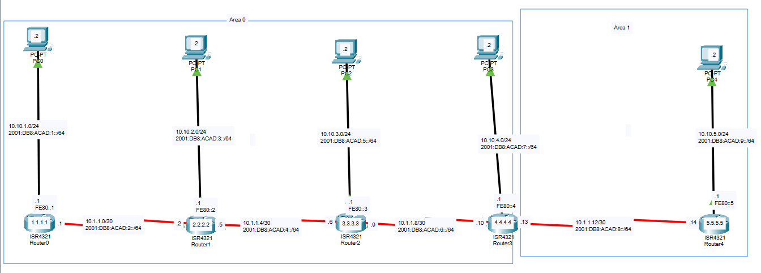

Configurations

Router0

Show Run

*Building configuration...*

*Current configuration : 1076 bytes*

*!*

*version 15.4*

*no service timestamps log datetime msec*

*no service timestamps debug datetime msec*

*no service password-encryption*

*!*

*hostname R0*

*!*

*!*

*!*

*!*

*!*

*!*

*!*

*!*

*no ip cef*

*ipv6 unicast-routing*

*!*

*no ipv6 cef*

*!*

*!*

*!*

*!*

*!*

*!*

*!*

*!*

*!*

*!*

*!*

*!*

*spanning-tree mode pvst*

*!*

*!*

*!*

*!*

*!*

*!*

*interface GigabitEthernet0/0/0*

*ip address 10.10.1.1 255.255.255.0*

*duplex auto*

*speed auto*

*ipv6 address FE80::1 link-local*

*ipv6 address 2001:DB8:ACAD:1::1/64*

*ipv6 ospf 1 area 0*

*!*

*interface GigabitEthernet0/0/1*

*no ip address*

*duplex auto*

*speed auto*

*shutdown*

*!*

*interface Serial0/1/0*

*ip address 10.1.1.1 255.255.255.252*

*ipv6 address FE80::1 link-local*

*ipv6 address 2001:DB8:ACAD:2::1/64*

*ipv6 ospf 1 area 0*

*!*

*interface Serial0/1/1*

*no ip address*

*clock rate 2000000*

*shutdown*

*!*

*interface Vlan1*

*no ip address*

*shutdown*

*!*

*router ospf 10*

*log-adjacency-changes*

*network 10.10.1.0 0.0.0.255 area 0*

*network 10.1.1.0 0.0.0.3 area 0*

*!*

*ipv6 router ospf 1*

*router-id 1.1.1.1*

*log-adjacency-changes*

*!*

*ip classless*

*!*

*ip flow-export version 9*

*!*

*!*

*!*

*!*

*!*

*!*

*!*

*!*

*line con 0*

*!*

*line aux 0*

*!*

*line vty 0 4*

*login*

*!*

*!*

*!*

*end*

Show IP Route

*Codes: L - local, C - connected, S - static, R - RIP, M - mobile, B - BGP*

*D - EIGRP, EX - EIGRP external, O - OSPF, IA - OSPF inter area*

*N1 - OSPF NSSA external type 1, N2 - OSPF NSSA external type 2*

*E1 - OSPF external type 1, E2 - OSPF external type 2, E - EGP*

*i - IS-IS, L1 - IS-IS level-1, L2 - IS-IS level-2, ia - IS-IS inter area*

*\* - candidate default, U - per-user static route, o - ODR*

*P - periodic downloaded static route*

*Gateway of last resort is not set*

*10.0.0.0/8 is variably subnetted, 11 subnets, 3 masks*

*C 10.1.1.0/30 is directly connected, Serial0/1/0*

*L 10.1.1.1/32 is directly connected, Serial0/1/0*

*O 10.1.1.4/30 [110/128] via 10.1.1.2, 00:04:03, Serial0/1/0*

*O 10.1.1.8/30 [110/192] via 10.1.1.2, 00:04:03, Serial0/1/0*

*O IA 10.1.1.12/30 [110/256] via 10.1.1.2, 00:03:53, Serial0/1/0*

*C 10.10.1.0/24 is directly connected, GigabitEthernet0/0/0*

*L 10.10.1.1/32 is directly connected, GigabitEthernet0/0/0*

*O 10.10.2.0/24 [110/65] via 10.1.1.2, 00:04:03, Serial0/1/0*

*O 10.10.3.0/24 [110/129] via 10.1.1.2, 00:04:03, Serial0/1/0*

*O 10.10.4.0/24 [110/193] via 10.1.1.2, 00:03:53, Serial0/1/0*

*O IA 10.10.5.0/24 [110/257] via 10.1.1.2, 00:03:53, Serial0/1/0*

Show IPv6 Route

*Codes: C - Connected, L - Local, S - Static, R - RIP, B - BGP*

*U - Per-user Static route, M - MIPv6*

*I1 - ISIS L1, I2 - ISIS L2, IA - ISIS interarea, IS - ISIS summary*

*O - OSPF intra, OI - OSPF inter, OE1 - OSPF ext 1, OE2 - OSPF ext 2*

*ON1 - OSPF NSSA ext 1, ON2 - OSPF NSSA ext 2*

*D - EIGRP, EX - EIGRP external*

*C 2001:DB8:ACAD:1::/64 [0/0]*

*via GigabitEthernet0/0/0, directly connected*

*L 2001:DB8:ACAD:1::1/128 [0/0]*

*via GigabitEthernet0/0/0, receive*

*C 2001:DB8:ACAD:2::/64 [0/0]*

*via Serial0/1/0, directly connected*

*L 2001:DB8:ACAD:2::1/128 [0/0]*

*via Serial0/1/0, receive*

*O 2001:DB8:ACAD:3::/64 [110/65]*

*via FE80::2, Serial0/1/0*

*O 2001:DB8:ACAD:4::/64 [110/128]*

*via FE80::2, Serial0/1/0*

*O 2001:DB8:ACAD:5::/64 [110/129]*

*via FE80::2, Serial0/1/0*

*O 2001:DB8:ACAD:6::/64 [110/192]*

*via FE80::2, Serial0/1/0*

*O 2001:DB8:ACAD:7::/64 [110/193]*

*via FE80::2, Serial0/1/0*

*OI 2001:DB8:ACAD:8::/64 [110/256]*

*via FE80::2, Serial0/1/0*

*OI 2001:DB8:ACAD:9::/64 [110/257]*

*via FE80::2, Serial0/1/0*

*L FF00::/8 [0/0]*

*via Null0, receive*

Router 1

Show Run

*Building configuration...*

*Current configuration : 1210 bytes*

*!*

*version 15.4*

*no service timestamps log datetime msec*

*no service timestamps debug datetime msec*

*no service password-encryption*

*!*

*hostname R1*

*!*

*!*

*!*

*!*

*!*

*!*

*!*

*!*

*no ip cef*

*ipv6 unicast-routing*

*!*

*no ipv6 cef*

*!*

*!*

*!*

*!*

*!*

*!*

*!*

*!*

*!*

*!*

*!*

*!*

*spanning-tree mode pvst*

*!*

*!*

*!*

*!*

*!*

*!*

*interface GigabitEthernet0/0/0*

*ip address 10.10.2.1 255.255.255.0*

*duplex auto*

*speed auto*

*ipv6 address FE80::2 link-local*

*ipv6 address 2001:DB8:ACAD:3::1/64*

*ipv6 ospf 1 area 0*

*!*

*interface GigabitEthernet0/0/1*

*no ip address*

*duplex auto*

*speed auto*

*shutdown*

*!*

*interface Serial0/1/0*

*ip address 10.1.1.5 255.255.255.252*

*ipv6 address FE80::2 link-local*

*ipv6 address 2001:DB8:ACAD:4::5/64*

*ipv6 ospf 1 area 0*

*!*

*interface Serial0/1/1*

*ip address 10.1.1.2 255.255.255.252*

*ipv6 address FE80::2 link-local*

*ipv6 address 2001:DB8:ACAD:2::2/64*

*ipv6 ospf 1 area 0*

*clock rate 2000000*

*!*

*interface Vlan1*

*no ip address*

*shutdown*

*!*

*router ospf 10*

*log-adjacency-changes*

*network 10.1.1.0 0.0.0.3 area 0*

*network 10.10.2.0 0.0.0.255 area 0*

*network 10.1.1.4 0.0.0.3 area 0*

*!*

*ipv6 router ospf 1*

*router-id 2.2.2.2*

*log-adjacency-changes*

*!*

*ip classless*

*!*

*ip flow-export version 9*

*!*

*!*

*!*

*!*

*!*

*!*

*!*

*!*

*line con 0*

*!*

*line aux 0*

*!*

*line vty 0 4*

*login*

*!*

*!*

*!*

*end*

Show IP Route

*Codes: L - local, C - connected, S - static, R - RIP, M - mobile, B - BGP*

*D - EIGRP, EX - EIGRP external, O - OSPF, IA - OSPF inter area*

*N1 - OSPF NSSA external type 1, N2 - OSPF NSSA external type 2*

*E1 - OSPF external type 1, E2 - OSPF external type 2, E - EGP*

*i - IS-IS, L1 - IS-IS level-1, L2 - IS-IS level-2, ia - IS-IS inter area*

*\* - candidate default, U - per-user static route, o - ODR*

*P - periodic downloaded static route*

*Gateway of last resort is not set*

*10.0.0.0/8 is variably subnetted, 12 subnets, 3 masks*

*C 10.1.1.0/30 is directly connected, Serial0/1/1*

*L 10.1.1.2/32 is directly connected, Serial0/1/1*

*C 10.1.1.4/30 is directly connected, Serial0/1/0*

*L 10.1.1.5/32 is directly connected, Serial0/1/0*

*O 10.1.1.8/30 [110/128] via 10.1.1.6, 00:09:30, Serial0/1/0*

*O IA 10.1.1.12/30 [110/192] via 10.1.1.6, 00:09:20, Serial0/1/0*

*O 10.10.1.0/24 [110/65] via 10.1.1.1, 00:09:30, Serial0/1/1*

*C 10.10.2.0/24 is directly connected, GigabitEthernet0/0/0*

*L 10.10.2.1/32 is directly connected, GigabitEthernet0/0/0*

*O 10.10.3.0/24 [110/65] via 10.1.1.6, 00:09:30, Serial0/1/0*

*O 10.10.4.0/24 [110/129] via 10.1.1.6, 00:09:20, Serial0/1/0*

*O IA 10.10.5.0/24 [110/193] via 10.1.1.6, 00:09:20, Serial0/1/0*

Show IPv6 Route

*IPv6 Routing Table - 13 entries*

*Codes: C - Connected, L - Local, S - Static, R - RIP, B - BGP*

*U - Per-user Static route, M - MIPv6*

*I1 - ISIS L1, I2 - ISIS L2, IA - ISIS interarea, IS - ISIS summary*

*O - OSPF intra, OI - OSPF inter, OE1 - OSPF ext 1, OE2 - OSPF ext 2*

*ON1 - OSPF NSSA ext 1, ON2 - OSPF NSSA ext 2*

*D - EIGRP, EX - EIGRP external*

*O 2001:DB8:ACAD:1::/64 [110/65]*

*via FE80::1, Serial0/1/1*

*C 2001:DB8:ACAD:2::/64 [0/0]*

*via Serial0/1/1, directly connected*

*L 2001:DB8:ACAD:2::2/128 [0/0]*

*via Serial0/1/1, receive*

*C 2001:DB8:ACAD:3::/64 [0/0]*

*via GigabitEthernet0/0/0, directly connected*

*L 2001:DB8:ACAD:3::1/128 [0/0]*

*via GigabitEthernet0/0/0, receive*

*C 2001:DB8:ACAD:4::/64 [0/0]*

*via Serial0/1/0, directly connected*

*L 2001:DB8:ACAD:4::5/128 [0/0]*

*via Serial0/1/0, receive*

*O 2001:DB8:ACAD:5::/64 [110/65]*

*via FE80::3, Serial0/1/0*

*O 2001:DB8:ACAD:6::/64 [110/128]*

*via FE80::3, Serial0/1/0*

*O 2001:DB8:ACAD:7::/64 [110/129]*

*via FE80::3, Serial0/1/0*

*OI 2001:DB8:ACAD:8::/64 [110/192]*

*via FE80::3, Serial0/1/0*

*OI 2001:DB8:ACAD:9::/64 [110/193]*

*via FE80::3, Serial0/1/0*

*L FF00::/8 [0/0]*

*via Null0, receive*

Router 2

Show Run

*Building configuration...*

*Current configuration : 1210 bytes*

*!*

*version 15.4*

*no service timestamps log datetime msec*

*no service timestamps debug datetime msec*

*no service password-encryption*

*!*

*hostname R2*

*!*

*!*

*!*

*!*

*!*

*!*

*!*

*!*

*no ip cef*

*ipv6 unicast-routing*

*!*

*no ipv6 cef*

*!*

*!*

*!*

*!*

*!*

*!*

*!*

*!*

*!*

*!*

*!*

*!*

*spanning-tree mode pvst*

*!*

*!*

*!*

*!*

*!*

*!*

*interface GigabitEthernet0/0/0*

*ip address 10.10.3.1 255.255.255.0*

*duplex auto*

*speed auto*

*ipv6 address FE80::3 link-local*

*ipv6 address 2001:DB8:ACAD:5::1/64*

*ipv6 ospf 1 area 0*

*!*

*interface GigabitEthernet0/0/1*

*no ip address*

*duplex auto*

*speed auto*

*shutdown*

*!*

*interface Serial0/1/0*

*ip address 10.1.1.9 255.255.255.252*

*ipv6 address FE80::3 link-local*

*ipv6 address 2001:DB8:ACAD:6::9/64*

*ipv6 ospf 1 area 0*

*!*

*interface Serial0/1/1*

*ip address 10.1.1.6 255.255.255.252*

*ipv6 address FE80::3 link-local*

*ipv6 address 2001:DB8:ACAD:4::6/64*

*ipv6 ospf 1 area 0*

*clock rate 2000000*

*!*

*interface Vlan1*

*no ip address*

*shutdown*

*!*

*router ospf 10*

*log-adjacency-changes*

*network 10.1.1.4 0.0.0.3 area 0*

*network 10.10.3.0 0.0.0.255 area 0*

*network 10.1.1.8 0.0.0.3 area 0*

*!*

*ipv6 router ospf 1*

*router-id 3.3.3.3*

*log-adjacency-changes*

*!*

*ip classless*

*!*

*ip flow-export version 9*

*!*

*!*

*!*

*!*

*!*

*!*

*!*

*!*

*line con 0*

*!*

*line aux 0*

*!*

*line vty 0 4*

*login*

*!*

*!*

*!*

*end*

Show IP Route

*Codes: L - local, C - connected, S - static, R - RIP, M - mobile, B - BGP*

*D - EIGRP, EX - EIGRP external, O - OSPF, IA - OSPF inter area*

*N1 - OSPF NSSA external type 1, N2 - OSPF NSSA external type 2*

*E1 - OSPF external type 1, E2 - OSPF external type 2, E - EGP*

*i - IS-IS, L1 - IS-IS level-1, L2 - IS-IS level-2, ia - IS-IS inter area*

*\* - candidate default, U - per-user static route, o - ODR*

*P - periodic downloaded static route*

*Gateway of last resort is not set*

*10.0.0.0/8 is variably subnetted, 10 subnets, 3 masks*

*O 10.1.1.0/30 [110/128] via 10.1.1.5, 00:10:36, Serial0/1/1*

*C 10.1.1.4/30 is directly connected, Serial0/1/1*

*L 10.1.1.6/32 is directly connected, Serial0/1/1*

*C 10.1.1.8/30 is directly connected, Serial0/1/0*

*L 10.1.1.9/32 is directly connected, Serial0/1/0*

*O 10.10.1.0/24 [110/129] via 10.1.1.5, 00:10:36, Serial0/1/1*

*O 10.10.2.0/24 [110/65] via 10.1.1.5, 00:10:36, Serial0/1/1*

*C 10.10.3.0/24 is directly connected, GigabitEthernet0/0/0*

*L 10.10.3.1/32 is directly connected, GigabitEthernet0/0/0*

*O 10.10.4.0/24 [110/65] via 10.1.1.10, 00:10:36, Serial0/1/0*

Show IPv6 Route

*IPv6 Routing Table - 13 entries*

*Codes: C - Connected, L - Local, S - Static, R - RIP, B - BGP*

*U - Per-user Static route, M - MIPv6*

*I1 - ISIS L1, I2 - ISIS L2, IA - ISIS interarea, IS - ISIS summary*

*O - OSPF intra, OI - OSPF inter, OE1 - OSPF ext 1, OE2 - OSPF ext 2*

*ON1 - OSPF NSSA ext 1, ON2 - OSPF NSSA ext 2*

*D - EIGRP, EX - EIGRP external*

*O 2001:DB8:ACAD:1::/64 [110/129]*

*via FE80::2, Serial0/1/1*

*O 2001:DB8:ACAD:2::/64 [110/128]*

*via FE80::2, Serial0/1/1*

*O 2001:DB8:ACAD:3::/64 [110/65]*

*via FE80::2, Serial0/1/1*

*C 2001:DB8:ACAD:4::/64 [0/0]*

*via Serial0/1/1, directly connected*

*L 2001:DB8:ACAD:4::6/128 [0/0]*

*via Serial0/1/1, receive*

*C 2001:DB8:ACAD:5::/64 [0/0]*

*via GigabitEthernet0/0/0, directly connected*

*L 2001:DB8:ACAD:5::1/128 [0/0]*

*via GigabitEthernet0/0/0, receive*

*C 2001:DB8:ACAD:6::/64 [0/0]*

*via Serial0/1/0, directly connected*

*L 2001:DB8:ACAD:6::9/128 [0/0]*

*via Serial0/1/0, receive*

*O 2001:DB8:ACAD:7::/64 [110/65]*

*via FE80::4, Serial0/1/0*

*OI 2001:DB8:ACAD:8::/64 [110/128]*

*via FE80::4, Serial0/1/0*

*OI 2001:DB8:ACAD:9::/64 [110/129]*

*via FE80::4, Serial0/1/0*

*L FF00::/8 [0/0]*

*via Null0, receive*

Router 3

Show Run

*Building configuration...*

*Current configuration : 1213 bytes*

*!*

*version 15.4*

*no service timestamps log datetime msec*

*no service timestamps debug datetime msec*

*no service password-encryption*

*!*

*hostname R3*

*!*

*!*

*!*

*!*

*!*

*!*

*!*

*!*

*no ip cef*

*ipv6 unicast-routing*

*!*

*no ipv6 cef*

*!*

*!*

*!*

*!*

*!*

*!*

*!*

*!*

*!*

*!*

*!*

*!*

*spanning-tree mode pvst*

*!*

*!*

*!*

*!*

*!*

*!*

*interface GigabitEthernet0/0/0*

*ip address 10.10.4.1 255.255.255.0*

*duplex auto*

*speed auto*

*ipv6 address FE80::4 link-local*

*ipv6 address 2001:DB8:ACAD:7::1/64*

*ipv6 ospf 1 area 0*

*!*

*interface GigabitEthernet0/0/1*

*no ip address*

*duplex auto*

*speed auto*

*shutdown*

*!*

*interface Serial0/1/0*

*ip address 10.1.1.13 255.255.255.252*

*ipv6 address FE80::4 link-local*

*ipv6 address 2001:DB8:ACAD:8::D/64*

*ipv6 ospf 1 area 1*

*!*

*interface Serial0/1/1*

*ip address 10.1.1.10 255.255.255.252*

*ipv6 address FE80::4 link-local*

*ipv6 address 2001:DB8:ACAD:6::A/64*

*ipv6 ospf 1 area 0*

*clock rate 2000000*

*!*

*interface Vlan1*

*no ip address*

*shutdown*

*!*

*router ospf 10*

*log-adjacency-changes*

*network 10.10.4.0 0.0.0.255 area 0*

*network 10.1.1.8 0.0.0.3 area 0*

*network 10.1.1.12 0.0.0.3 area 1*

*!*

*ipv6 router ospf 1*

*router-id 4.4.4.4*

*log-adjacency-changes*

*!*

*ip classless*

*!*

*ip flow-export version 9*

*!*

*!*

*!*

*!*

*!*

*!*

*!*

*!*

*line con 0*

*!*

*line aux 0*

*!*

*line vty 0 4*

*login*

*!*

*!*

*!*

*end*

Show IP Route

*Codes: L - local, C - connected, S - static, R - RIP, M - mobile, B - BGP*

*D - EIGRP, EX - EIGRP external, O - OSPF, IA - OSPF inter area*

*N1 - OSPF NSSA external type 1, N2 - OSPF NSSA external type 2*

*E1 - OSPF external type 1, E2 - OSPF external type 2, E - EGP*

*i - IS-IS, L1 - IS-IS level-1, L2 - IS-IS level-2, ia - IS-IS inter area*

*\* - candidate default, U - per-user static route, o - ODR*

*P - periodic downloaded static route*

*Gateway of last resort is not set*

*10.0.0.0/8 is variably subnetted, 12 subnets, 3 masks*

*O 10.1.1.0/30 [110/192] via 10.1.1.9, 00:24:12, Serial0/1/1*

*O 10.1.1.4/30 [110/128] via 10.1.1.9, 01:09:31, Serial0/1/1*

*C 10.1.1.8/30 is directly connected, Serial0/1/1*

*L 10.1.1.10/32 is directly connected, Serial0/1/1*

*C 10.1.1.12/30 is directly connected, Serial0/1/0*

*L 10.1.1.13/32 is directly connected, Serial0/1/0*

*O 10.10.1.0/24 [110/193] via 10.1.1.9, 00:24:12, Serial0/1/1*

*O 10.10.2.0/24 [110/129] via 10.1.1.9, 00:24:12, Serial0/1/1*

*O 10.10.3.0/24 [110/65] via 10.1.1.9, 01:09:31, Serial0/1/1*

*C 10.10.4.0/24 is directly connected, GigabitEthernet0/0/0*

*L 10.10.4.1/32 is directly connected, GigabitEthernet0/0/0*

*O 10.10.5.0/24 [110/65] via 10.1.1.14, 00:24:27, Serial0/1/0*

Router 4

Show Run

*Building configuration...*

*Current configuration : 1098 bytes*

*!*

*version 15.4*

*no service timestamps log datetime msec*

*no service timestamps debug datetime msec*

*no service password-encryption*

*!*

*hostname R4*

*!*

*!*

*!*

*!*

*!*

*!*

*!*

*!*

*no ip cef*

*ipv6 unicast-routing*

*!*

*no ipv6 cef*

*!*

*!*

*!*

*!*

*!*

*!*

*!*

*!*

*!*

*!*

*!*

*!*

*spanning-tree mode pvst*

*!*

*!*

*!*

*!*

*!*

*!*

*interface GigabitEthernet0/0/0*

*ip address 10.10.5.1 255.255.255.0*

*duplex auto*

*speed auto*

*ipv6 address FE80::5 link-local*

*ipv6 address 2001:DB8:ACAD:9::1/64*

*ipv6 ospf 1 area 1*

*!*

*interface GigabitEthernet0/0/1*

*no ip address*

*duplex auto*

*speed auto*

*shutdown*

*!*

*interface Serial0/1/0*

*no ip address*

*clock rate 2000000*

*shutdown*

*!*

*interface Serial0/1/1*

*ip address 10.1.1.14 255.255.255.252*

*ipv6 address FE80::5 link-local*

*ipv6 address 2001:DB8:ACAD:8::E/64*

*ipv6 ospf 1 area 1*

*clock rate 2000000*

*!*

*interface Vlan1*

*no ip address*

*shutdown*

*!*

*router ospf 10*

*log-adjacency-changes*

*network 10.1.1.12 0.0.0.3 area 1*

*network 10.10.5.0 0.0.0.255 area 1*

*!*

*ipv6 router ospf 1*

*router-id 5.5.5.5*

*log-adjacency-changes*

*!*

*ip classless*

*!*

*ip flow-export version 9*

*!*

*!*

*!*

*!*

*!*

*!*

*!*

*!*

*line con 0*

*!*

*line aux 0*

*!*

*line vty 0 4*

*login*

*!*

*!*

*!*

*end*

Show IP Route

*Codes: L - local, C - connected, S - static, R - RIP, M - mobile, B - BGP*

*D - EIGRP, EX - EIGRP external, O - OSPF, IA - OSPF inter area*

*N1 - OSPF NSSA external type 1, N2 - OSPF NSSA external type 2*

*E1 - OSPF external type 1, E2 - OSPF external type 2, E - EGP*

*i - IS-IS, L1 - IS-IS level-1, L2 - IS-IS level-2, ia - IS-IS inter area*

*\* - candidate default, U - per-user static route, o - ODR*

*P - periodic downloaded static route*

*Gateway of last resort is not set*

*10.0.0.0/8 is variably subnetted, 11 subnets, 3 masks*

*O IA 10.1.1.0/30 [110/256] via 10.1.1.13, 00:57:10, Serial0/1/1*

*O IA 10.1.1.4/30 [110/192] via 10.1.1.13, 00:57:35, Serial0/1/1*

*O IA 10.1.1.8/30 [110/128] via 10.1.1.13, 00:57:35, Serial0/1/1*

*C 10.1.1.12/30 is directly connected, Serial0/1/1*

*L 10.1.1.14/32 is directly connected, Serial0/1/1*

*O IA 10.10.1.0/24 [110/257] via 10.1.1.13, 00:57:10, Serial0/1/1*

*O IA 10.10.2.0/24 [110/193] via 10.1.1.13, 00:57:10, Serial0/1/1*

*O IA 10.10.3.0/24 [110/129] via 10.1.1.13, 00:57:35, Serial0/1/1*

*O IA 10.10.4.0/24 [110/65] via 10.1.1.13, 00:57:35, Serial0/1/1*

*C 10.10.5.0/24 is directly connected, GigabitEthernet0/0/0*

*L 10.10.5.1/32 is directly connected, GigabitEthernet0/0/0*

Show IPv6 Route

*Codes: C - Connected, L - Local, S - Static, R - RIP, B - BGP*

*U - Per-user Static route, M - MIPv6*

*I1 - ISIS L1, I2 - ISIS L2, IA - ISIS interarea, IS - ISIS summary*

*O - OSPF intra, OI - OSPF inter, OE1 - OSPF ext 1, OE2 - OSPF ext 2*

*ON1 - OSPF NSSA ext 1, ON2 - OSPF NSSA ext 2*

*D - EIGRP, EX - EIGRP external*

*OI 2001:DB8:ACAD:1::/64 [110/257]*

*via FE80::4, Serial0/1/1*

*OI 2001:DB8:ACAD:2::/64 [110/256]*

*via FE80::4, Serial0/1/1*

*OI 2001:DB8:ACAD:3::/64 [110/193]*

*via FE80::4, Serial0/1/1*

*OI 2001:DB8:ACAD:4::/64 [110/192]*

*via FE80::4, Serial0/1/1*

*OI 2001:DB8:ACAD:5::/64 [110/129]*

*via FE80::4, Serial0/1/1*

*OI 2001:DB8:ACAD:6::/64 [110/128]*

*via FE80::4, Serial0/1/1*

*OI 2001:DB8:ACAD:7::/64 [110/65]*

*via FE80::4, Serial0/1/1*

*C 2001:DB8:ACAD:8::/64 [0/0]*

*via Serial0/1/1, directly connected*

*L 2001:DB8:ACAD:8::E/128 [0/0]*

*via Serial0/1/1, receive*

*C 2001:DB8:ACAD:9::/64 [0/0]*

*via GigabitEthernet0/0/0, directly connected*

*L 2001:DB8:ACAD:9::1/128 [0/0]*

*via GigabitEthernet0/0/0, receive*

*L FF00::/8 [0/0]*

*via Null0, receive*

Problems

The problem I encounter is that different networks were not connected, and I knew that because I can ping IP addresses within each network. The problem is that there were not any network statements under OSPFv2. I solved the problem by entering network statements under all routers.

Conclusion

In this lab, I reviewed the concept of assigning IP address and OSPF from last year’s curriculum. The Lab took about 80 minutes total. About half of the time was used to plan out IP addresses and other half of the time used to enter commands.

PC0 ping PC1

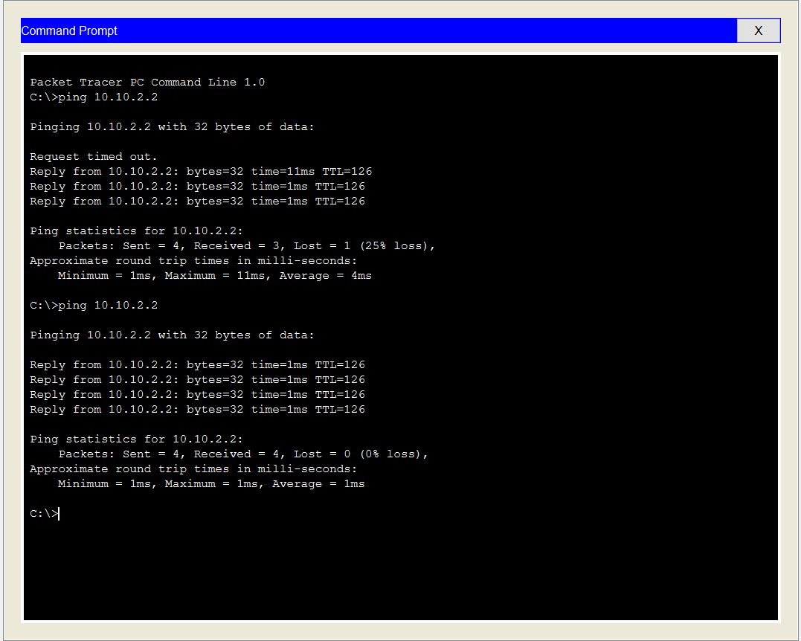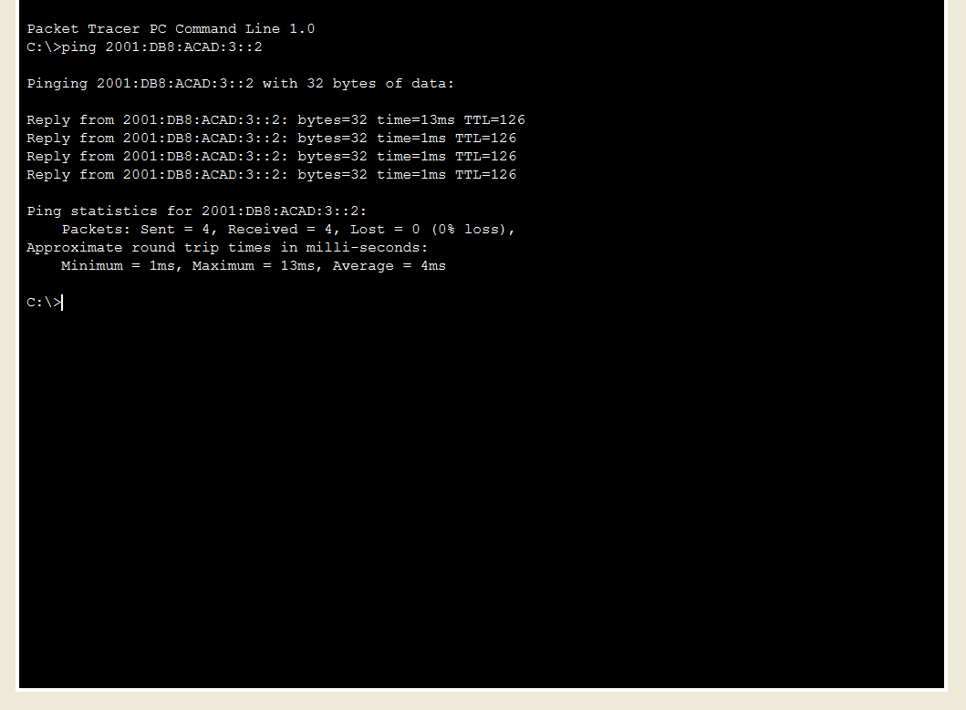

PC0 ping PC2

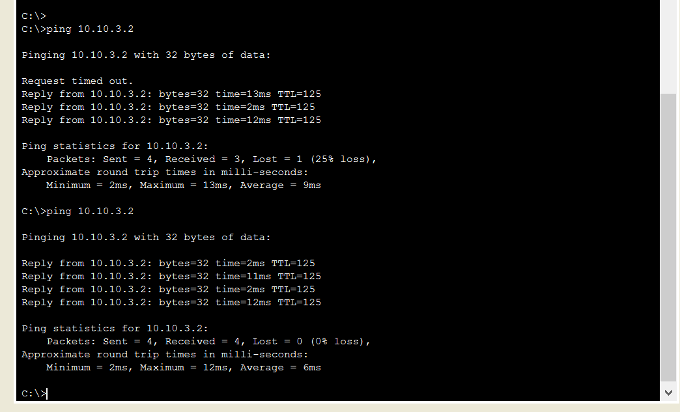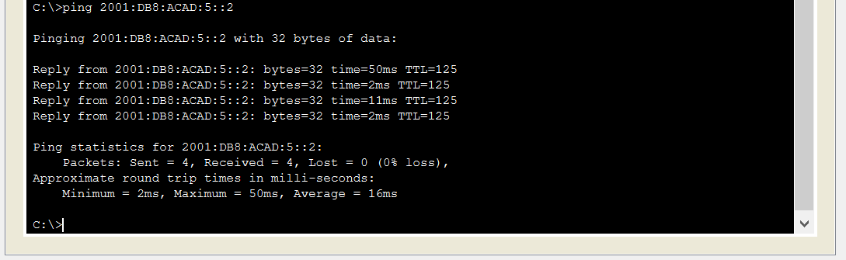

PC0 ping PC3

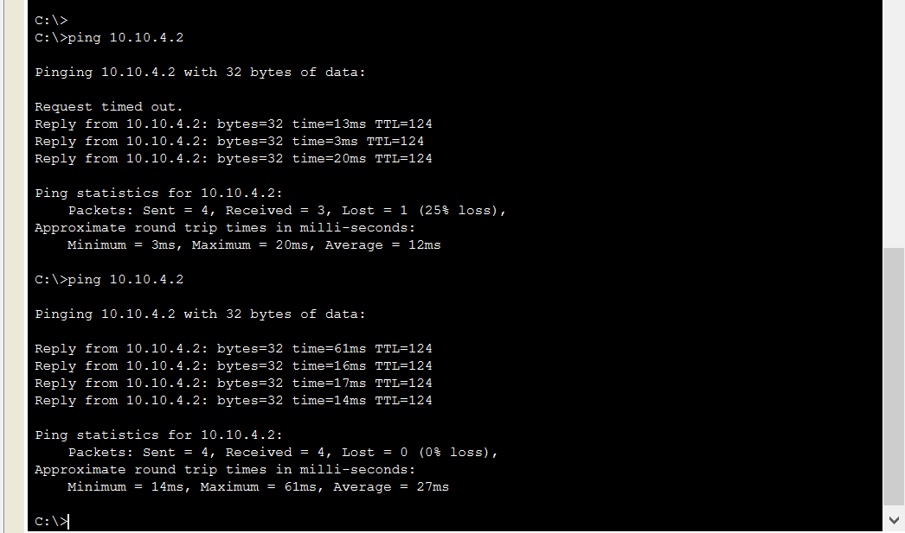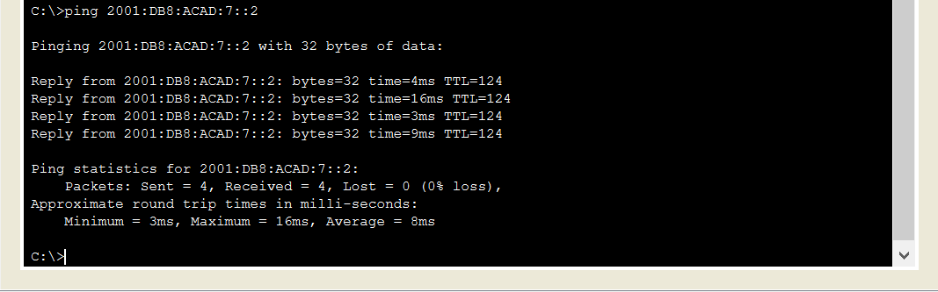

PC0 ping PC4

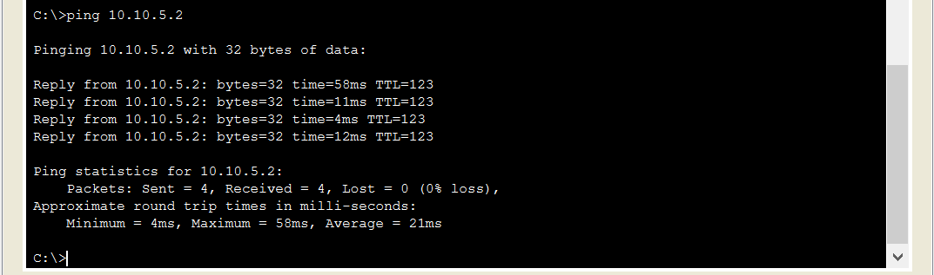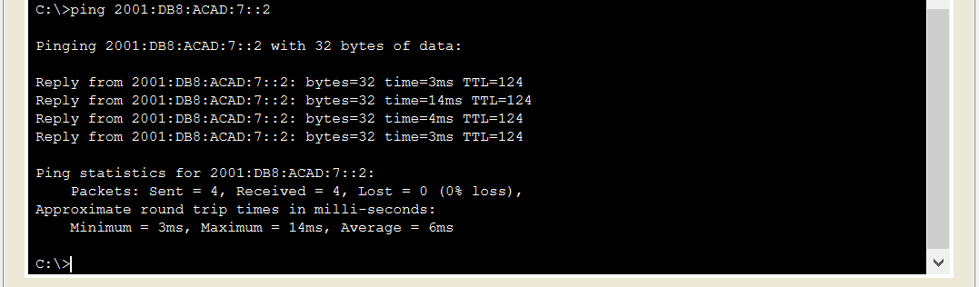

Teacher Signoff Page of Lab Completed